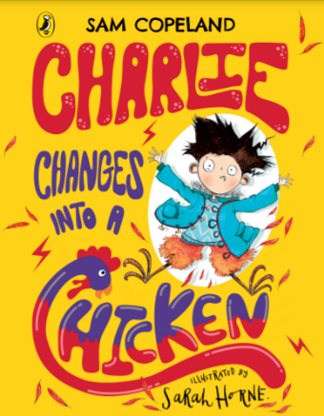
Monday 7th January 2022
LO: To understand that some emotions are bigger than others
C: Mental Health Week
C: Charlie Changes into a Chicken

I worked with . . . . . . . . . . . . . . . . . . . . . . . . . . . . . . . . . . . . . . . . . . . . . . . . . . . . .



