2.3.2022 L.O: To use measures. C: Give Change
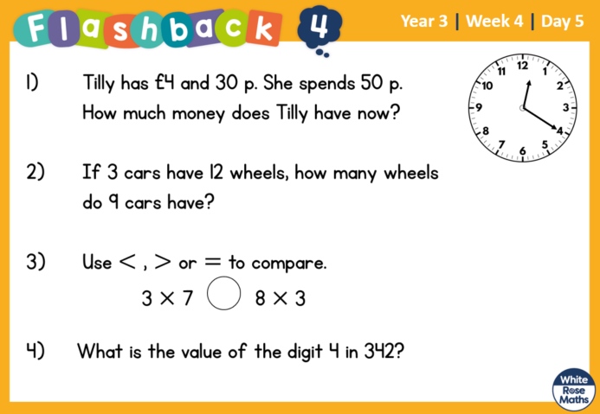
2.3.2022 L.O: To use measures. C: Give Change
2.3.2022 L.O: To use measures. C: Give Change

