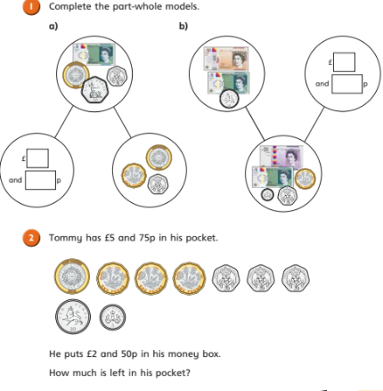
a) £3 and 50p – £1 and 20p =
b) £3 – £1 and 50p =
c) £6 and 15p – £2 and 85p =
d) £8.07 – £3.54 =
e) £4.34- £2.18=
Try these examples using column subtraction in your book.

a) £3 and 50p – £1 and 20p =
b) £3 – £1 and 50p =
c) £6 and 15p – £2 and 85p =
d) £8.07 – £3.54 =
e) £4.34- £2.18=
Try these examples using column subtraction in your book.

