1.3.2022 L.O: To use measures. C: Subtracting Money
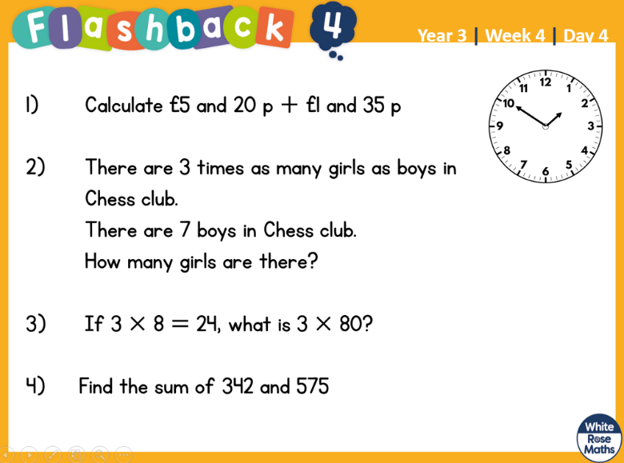

1.3.2022 L.O: To use measures. C: Subtracting Money

1.3.2022 L.O: To use measures. C: Subtracting Money

