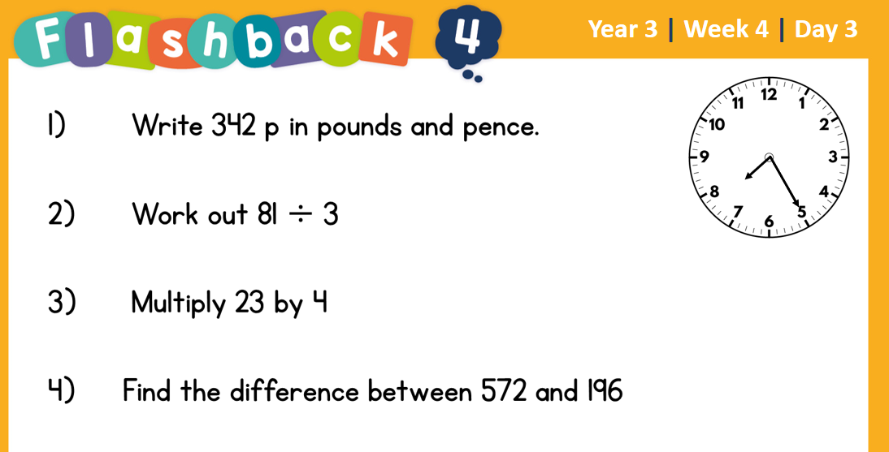
28.2.2022 L.O: To use measures. C: Adding Money
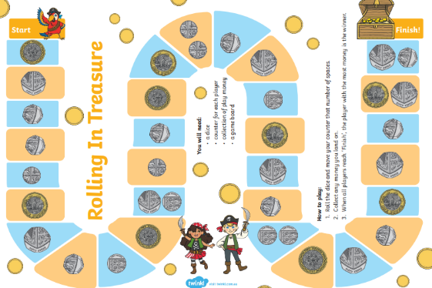
Today we played this game with the play money! My total was £
You can see a photo of us playing on Twitter!

28.2.2022 L.O: To use measures. C: Adding Money
Today we played this game with the play money! My total was £
You can see a photo of us playing on Twitter!

