Tuesday 22nd February 2022
LO: To use imaginative description
C: Newspaper Report Headlines

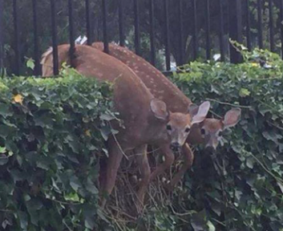

Tuesday 22nd February 2022
LO: To use imaginative description
C: Newspaper Report Headlines

