
Thursday 20th January 2022
L.O: To use connectives that inject suspense.
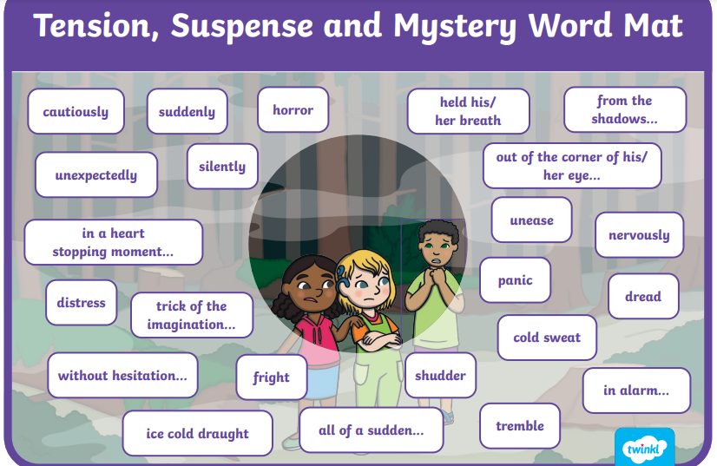
C: Mystery Story
Task 1: Can you edit and improve this paragraph in your book?
Josie looked at the time. It was four o’clock. Time to take out Buster. She didn’t want to go outside but she knew she had to. She got the lead and the keys and went downstairs to find her dog. The back door was wide open. Buster was gone.

Task 2: Can you write your own mystery paragraph using this photo as your inspiration? RED PEN: Highlight the words and phrases from the word mat you have used.

