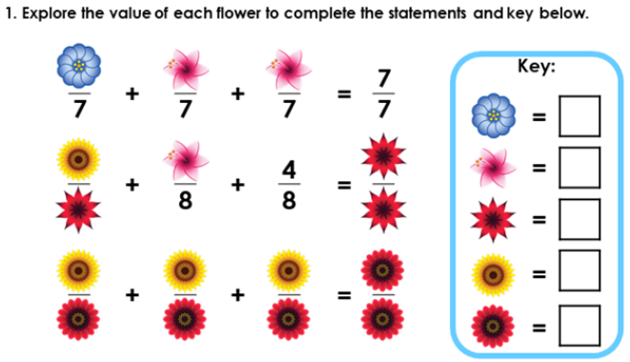
Divers: Red Pen Question
Divers: Red Pen Question
Divers: Red Pen Question

