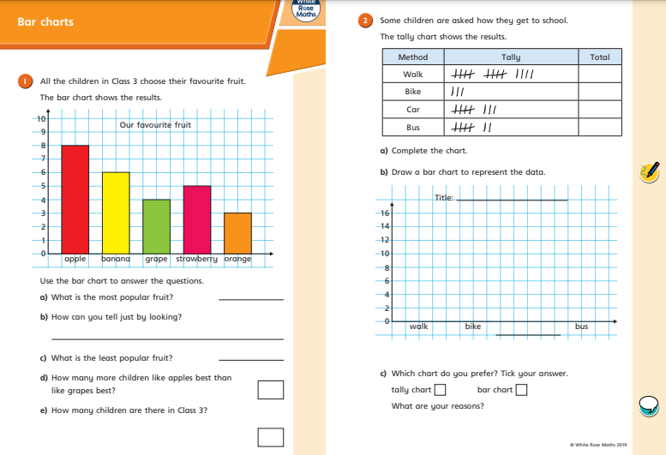


RED PEN: What are your 3 top tips for creating bar charts?

