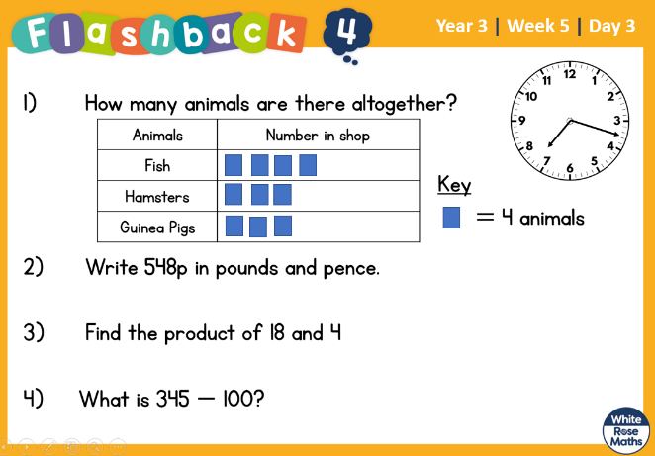
11.3.2022 L.O: To use statistics. C: Bar Charts

11.3.2022 L.O: To use statistics. C: Bar Charts

11.3.2022 L.O: To use statistics. C: Bar Charts

