
Compound Sentences
Wednesday 22nd September 2021
LO: To practice compound sentences
C: Finding Something Tale

Write seven sentences below ensuring each sentence has a different conjunction.

- _________________________________________________________
- _________________________________________________________
- _________________________________________________________
- _________________________________________________________
- _________________________________________________________
- _________________________________________________________
- _________________________________________________________

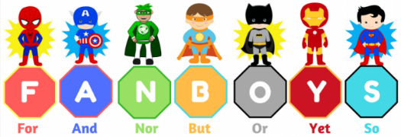

Compound Sentences
Wednesday 22nd September 2021
LO: To practice compound sentences
C: Finding Something Tale

Write seven sentences below ensuring each sentence has a different conjunction.

- _________________________________________________________
- _________________________________________________________
- _________________________________________________________
- _________________________________________________________
- _________________________________________________________
- _________________________________________________________
- _________________________________________________________

