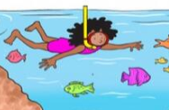
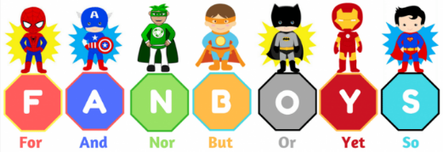
Wednesday 22nd September 2021
LO: To practice compound sentences
C: Finding Something Tale

- Jasper was determined to go on an adventure ________ he applied for an Egyptian adventure expedition.
- Jasper carefully reached down for the amulet _______ he picked it up hesitantly.
- He had never been to Egypt _______ had he ever left England.
- He needed lots of water for ______________________________________
- The pyramid was dark and scary _______ he was determined to complete his mission.
- Jasper wanted some company on his trip but ______________________________
- He could enter the tomb immediately or _________________________________
______________________________
Compound Sentences

Wednesday 22nd September 2021
LO: To practice compound sentences
C: Finding Something Tale

- Jasper was determined to go on an adventure ________ he applied for an Egyptian adventure expedition.
- Jasper carefully reached down for the amulet _______ he picked it up hesitantly.
- He had never been to Egypt _______ had he ever left England.
- He needed lots of water for ______________________________________
- The pyramid was dark and scary _______ he was determined to complete his mission.
- Jasper wanted some company on his trip but ______________________________
- He could enter the tomb immediately or _________________________________
______________________________
Compound Sentences

