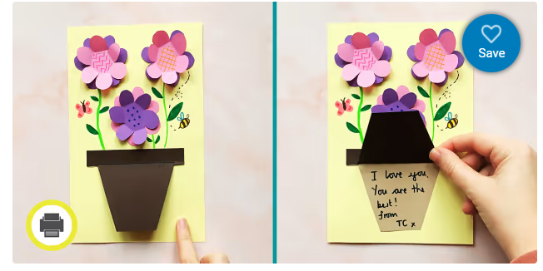
https://www.twinkl.co.uk/resource/mothers-day-flower-pot-card-mothers-day-card-craft-t-tc-1643117580

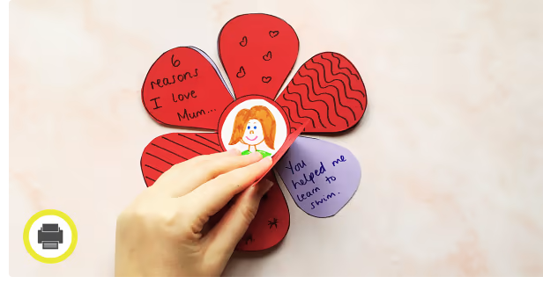
https://www.twinkl.co.uk/resource/mothers-day-flower-card-craft-mothers-day-card-idea-t-tc-1643117440

