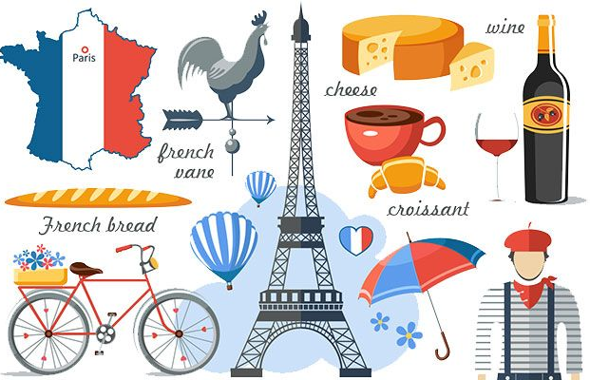
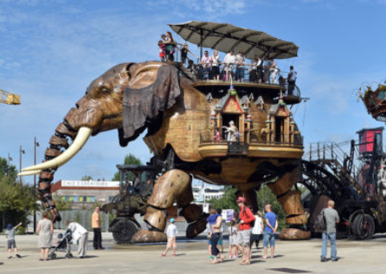

Red Pen:

My name is …………………. and I think ……………………………………..’s sentence means:

_____________________________________________________________________________________________________________________________________________________________________________________________________________________________________________________________________

Can you draw your own elephant and write a sentence to describe where it is?

________________________________________________________________________________________________________________________________________________________________________________________________________________

Culture:

In France, the “Elephant of Nantes” is a giant mechanical elephant you can ride!

Mardi 22 Mars 2022
Où est l'éléphant?

