
Wednesday 1st November 2021
LO: To write with purpose
C: Planning a non-chronological report
C: Determiners

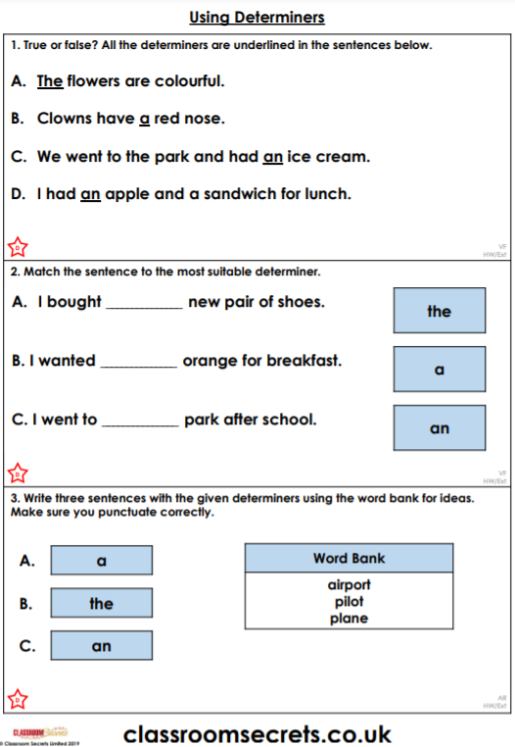
Today, we finished our plans by researching, and adding in, any information we needed in order to be able to write our non-chronological reports. Then, we looked at determiners as these will be used in our writing.

