Monday 29th November 2021
LO: To write with purpose
C: Features of a non-chronological report

Today, we looked at a variety of non-chronological reports. The features of this type of writing are hidden in the Word Search below:

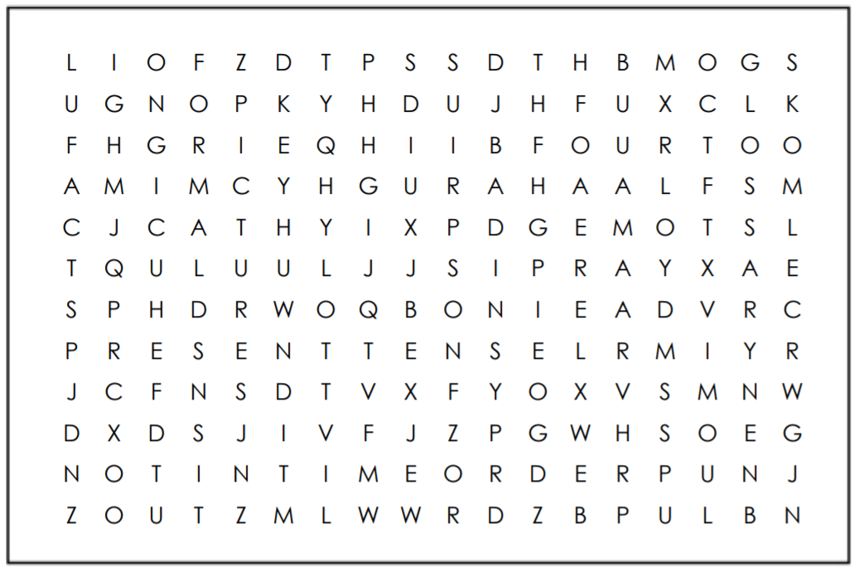

RPQ: When are non-chronological reports not written in the present tense?

