Non-chronolgoical Report
(This is a formal piece of writing that is used to give information on something. It can be found in books eg an animal book)
Features  - Not in time order  - Formal  - Present tense (usually! Unless it is about something in the past e.g. a historical report)  - 3rd person  - Sub-headings  - Includes facts |  | Plan:  P I E  Main purpose: Inform  One aspect  (eg Appearance)  Intro  (general sentences about topic)  Another aspect  (eg Habitat)  Another aspect  (eg Diet)  Conclusion – pick out main sentence from each paragraph  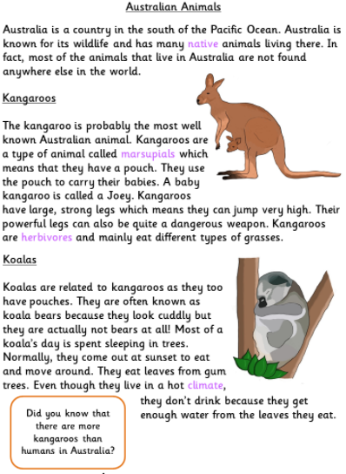 | Organisation  - Paragraphs can come in any order  - Intro should be generalised. To write a good intro, consider starting broad, then getting to the point you are writing about.  All  Most  Some  Sentence to end  Cats can be found all across the world. Most cats are domestic creatures, residing as pets. Some cats however, such as the ……cat, prefer to live in the wild. Little is known about this fantastic creature.  All – could be changed to Everywhere/everyone  Most – could be changed to Many, lots of, the majority  Some – could be changed to a few, a couple, a small minority  - Each paragraph starts with a general topic sentence and ideally, 3 subsequent sentences  - Ensure each paragraph flows from one another using linking phrases Eg. Another feature of the ...  - As well as….  - With its….  - Even though....
Grammar
- A variety of tenses
- Standard English
- Fronted adverbials
- Determiners
- (others, some, most, many)

Word Bank
typically
usually
mostly
frequently
aspect
feature
appearance
fundamental
Top Tips
You could include a fact box, glossary or labelled diagram.

