
29.11.2021
L.O: To use addition and subtraction
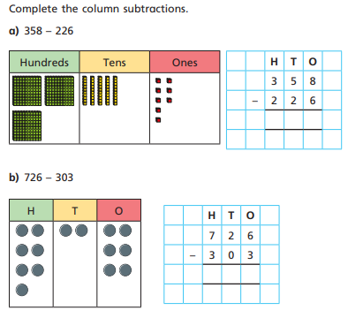
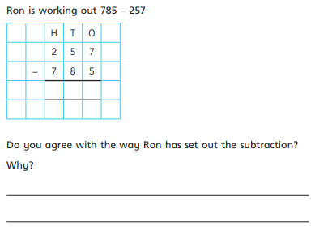
C: Subtract a 3 digit number from a 3 digit number – no exchange

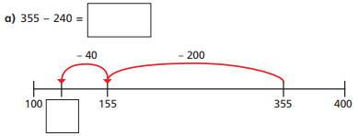
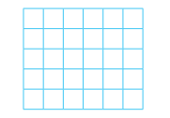
RED PEN: Can you show how you would solve this question?

