
29.11.2021
L.O: To use addition and subtraction
C: Subtract a 3 digit number from a 3 digit number – no exchange
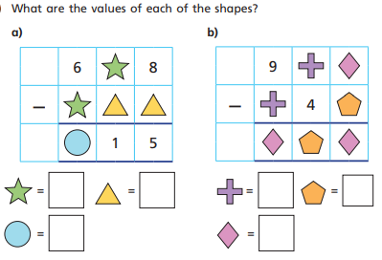
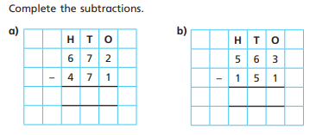

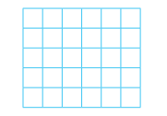
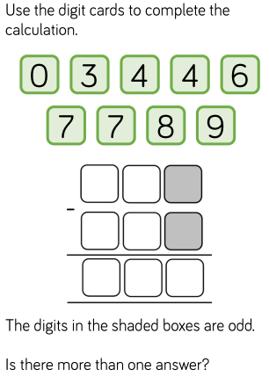
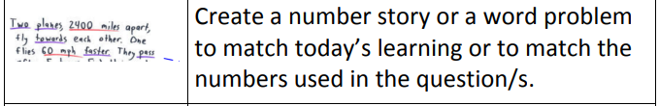
RED PEN: Can you write your own 3-digit subtraction word problem in your book?

