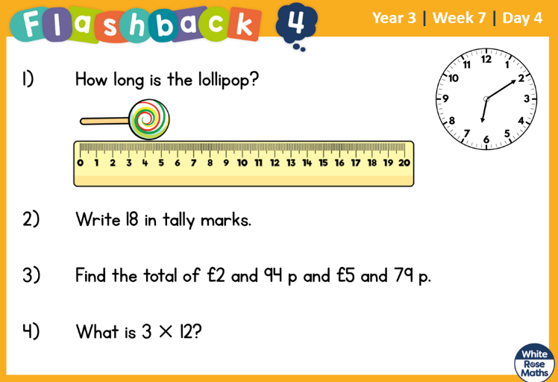
1.4.2022 L.O: To use measures. C: Add lengths

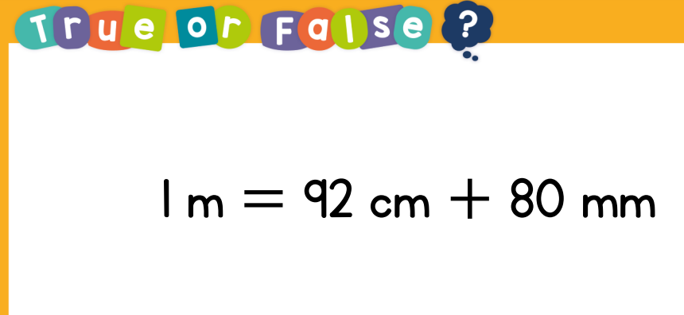

1.4.2022 L.O: To use measures. C: Add lengths

