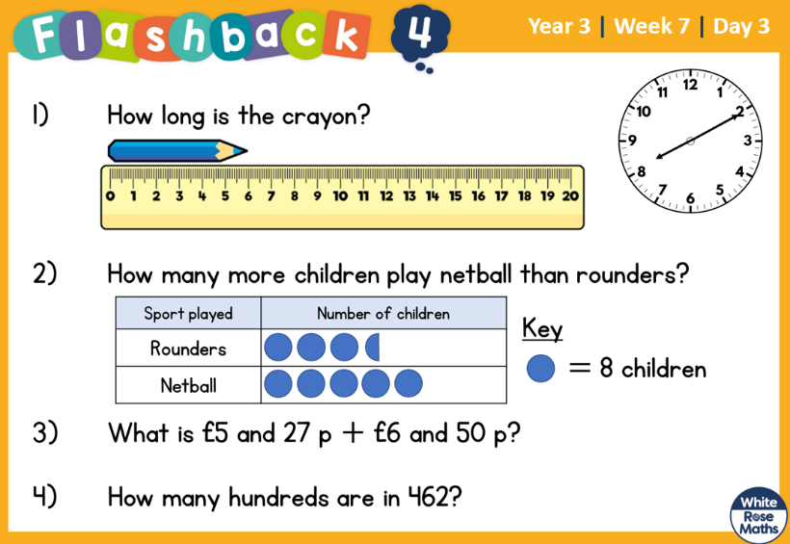
31.3.2022 L.O: To use measures. C: Compare lengths

31.3.2022 L.O: To use measures. C: Compare lengths

31.3.2022 L.O: To use measures. C: Compare lengths

