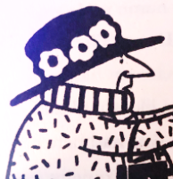
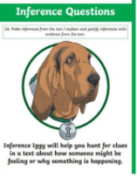
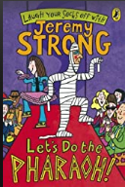
Thursday 14th October 2021
LO: To understand texts
C: Let’s do the Pharaoh! (Inference).

