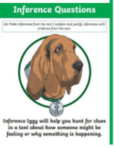

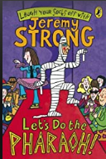
Monday 11th September 2021
LO: To understand texts
C: NFER style questions.

1. Read paragraph 3 on page 112, find and copy how Grimstone broke into the Lightspeed’s house. (1 mark)
2. Read paragraph 2 on page 113. Can you number these events 1-4? Number 1 has been done for you.
- they swept everything off the shelves
- they opened the wardrobes
- they tipped out the drawers
1
- they pulled out all the clothes
3. “I’m not sure about this... “began Jelly (page 114). How is Jelly feeling? Why do you think he is feeling that way? (2 marks)

Monday 11th September 2021
LO: To understand texts
C: NFER style questions.

1. Read paragraph 3 on page 112, find and copy how Grimstone broke into the Lightspeed’s house. (1 mark)
2. Read paragraph 2 on page 113. Can you number these events 1-4? Number 1 has been done for you.
- they swept everything off the shelves
- they opened the wardrobes
- they tipped out the drawers
1
- they pulled out all the clothes
3. “I’m not sure about this... “began Jelly (page 114). How is Jelly feeling? Why do you think he is feeling that way? (2 marks)

