How did the Egptians believe they got to the Afrerlife?

The Egyptians believed that when they died, their souls left their bodies. In this guide, readers will leave about the different stages of the afterlife and why they were important to the Egyptians. The method the Egyptians are famous for using was fully developed by 3400BC.

The Mummification Process

Firstly, the body was taken to a place called ‘The Beautiful House’. It was not as beautiful as the name suggests!
Here, the body was cleansed with palm wine and rinsed with water from the River Nile. Sometimes they would use a slatted bed on a slant. This would let the fluids drain off and out of the body.

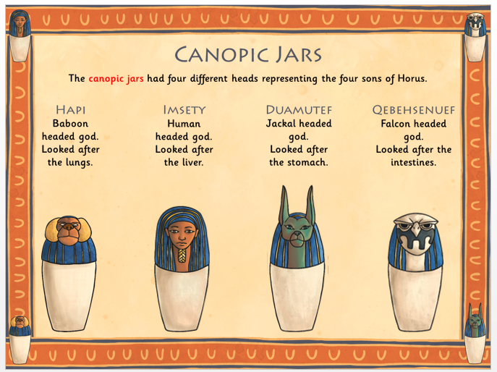
Next, an incision was made on the left side of the body and the organs were removed to stop the body from decomposing. The liver, lungs, intestines and stomach were washed, dried in natron and either wrapped in cloth or stored in canopic jars. The heart, responsible for intelligence and emotion, was left in the body as it was needed in the afterlife. The body was then stuffed with sawdust, rags or leaves, to help it maintain its shape.

The final organ to be removed was the brain. The brain was not thought to be important, so a long hook was inserted up the nose to break the brain into small pieces. The hook would then pull out the smaller parts of the brain through the nasal passage or the body was lifted so that the liquefied brain would drain through the nose. Using a hook meant that no damage was made to the head or the skull.

Following the removal of the internal organs, the body was dried inside and outside with natron salt. The natron absorbed the moisture from the body and took up to 70 days.

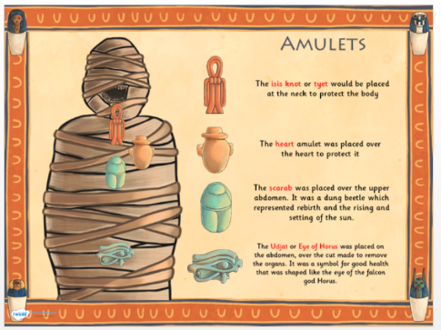
To further preserve the body, it was wrapped in strips of linen. Hundreds of metres of linen were used and the body could be wrapped in up to twenty layers thick. Between the layers of linen, they would place amulets, which would protect the dead person in the afterlife. The strips of linen were glued together with a tar like paste called ‘mummia’. This is where the term ‘mummy’ derives from. Whilst the wrapping took place, a priest wearing the mask of Anubis, would read out spells to ward off evil spirits and help the person on their journey to the afterlife.

Egyptian Coffins

A death mask, which looked like the person when they were alive, was made and put on top of the mummy so that their soul could find them.
The mummy was then placed inside a wooden coffin and this coffin may be placed inside another coffin. The coffins were elaborately decorated. The inside coffin would be painted and shaped like a body. The outer coffin would sometimes have eyes painted on it so that the person could see out and a false door on the inside so that the person could step out. The outside was often decorated with hieroglyphics.

The Funeral

A funeral would be held and funeral songs would be sung. A ritual called ‘The opening of the Mouth’ was performed so that the dead person would be able to eat, drink and speak in the afterlife.
The final stage of the process was to put the coffins into a sarcophagus and place it in a tomb with valuable objects, food and drink for the journey to the afterlife.

