Explanation
(Explains HOW or WHY something works or happens)
Features  - Titles is a question that starts with “How” or “Why”  - Formal language  - 3rd person  - Present tense  - Sub-headings  - Causal/cause and effect conjunctions  - Chronological order  - Technical vocab (coil, axle, pedal, drive, shaft) |  | Plan:  Explanation of exactly how / why  Intro – brief outline of what the writing is about  Optional additional paragraph for more detail or to explain another section  Conclusion – can be just one sentence  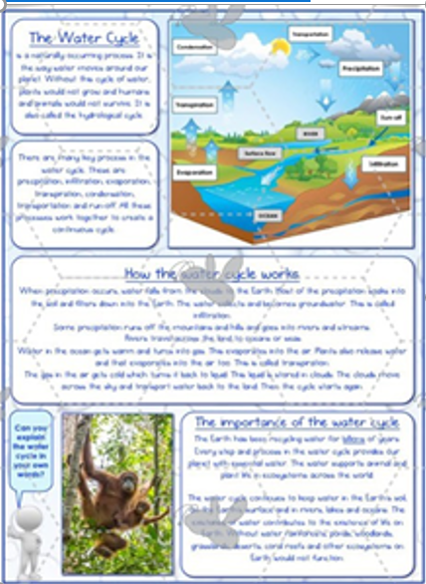  P I E  Main purpose: Inform | Causal conjunctions/phrases  If….then….  This means that  Once…then….  As a result  So that  Even though  Consequently  In order for…  In order to….
Useful Phrases  This explanation will….  It can be difficult to …. so …..  The purpose of this….  In addition …  Everyone understands that.. | Many people believe …  It is true to say that …  In general ….  Nobody knows why …. |  | Word Bank  Straightforward, ingenious  Powerful, delightful, available, assist, enables, confidently, effortlessly, | efficiently, speedily, swiftly, without fuss, collects  Extracts, ejects, deposits, solution, answer, features.
Grammar  - Variety of conjunctions  - Passive voice (The damage caused by the huge mass of water behind the initial wave front.)  - Colons (The tsunami caused a lot of damage: buildings were destroyed and crops flooded and ruined.) |  |  | Top Tips  - For the very first sentence, just use a general sentence that says what you are writing about.  “A Sycamore is a type of tree.”  - Include a labelled diagram to help the reader understand  - Where possible, try and link the end paragraph back to the introduction.

