Tuesday 2nd November 2021 LO: To write with purpose C: Mummification Process Plan
The Process of Mummification
Picture | Details: Clean
 | Organs
 | Brain
 | Dry
Stuff
Wrap
Coffin

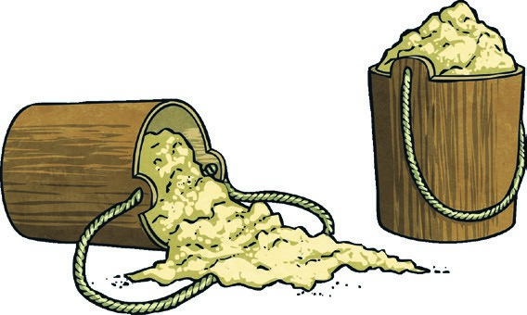  twinkl.com | 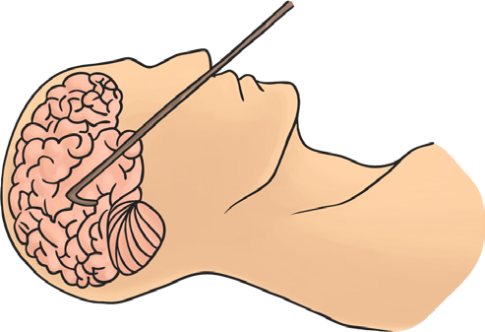  twinkl.com
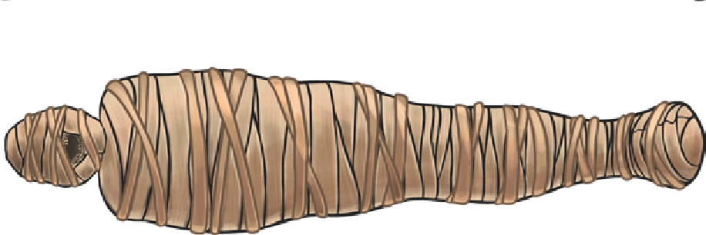  twinkl.com | 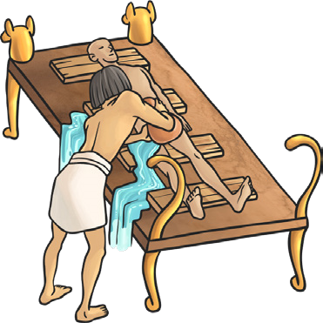 twinkl.com
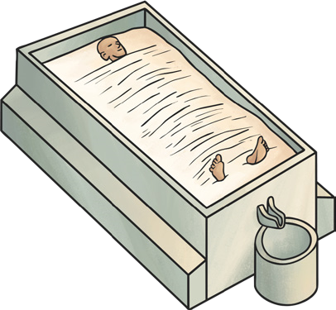  twinkl.com | 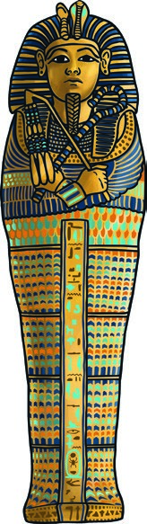  twinkl.com
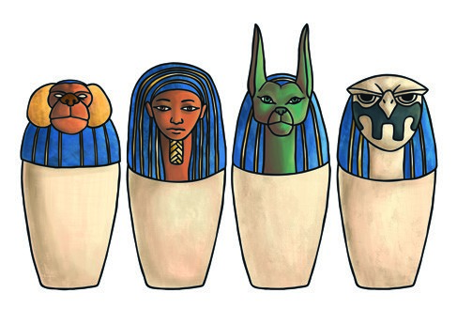
twinkl.com

