
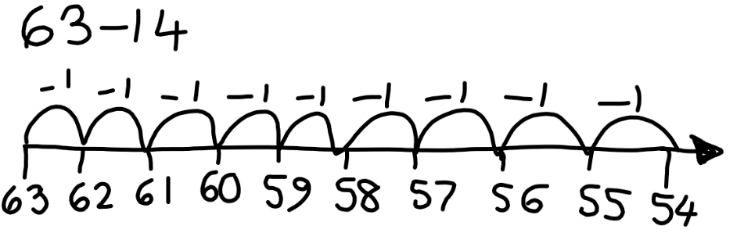


Red Pen:
Buddy has started solving this problem. Do you think he is using the most efficient method? How would you solve this problem?

Red Pen:
Buddy has started solving this problem. Do you think he is using the most efficient method? How would you solve this problem?

Red Pen:
Buddy has started solving this problem. Do you think he is using the most efficient method? How would you solve this problem?

