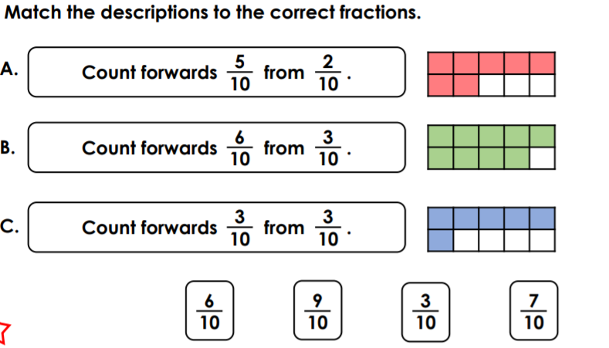
Paddlers Red Pen Question
Paddlers Red Pen Question
Paddlers Red Pen Question

