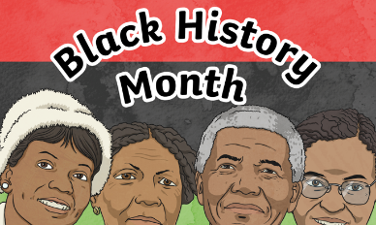
Tuesday 19th October 2021
L.O: To write with purpose.
C: Biography

Starter:
Activity 1: Add the possessive apostrophe into each sentence.
- Aretha Franklins legacy reigns on.
- Lennox Lewis childhood was troubled by fighting.
Activity 2: What is the mistake in this sentence?
- Martin Luther Kings s’peech has’ inspired people all over the world.

Tuesday 19th October 2021
L.O: To write with purpose.
C: Biography

Starter:
Activity 1: Add the possessive apostrophe into each sentence.
- Aretha Franklins legacy reigns on.
- Lennox Lewis childhood was troubled by fighting.
Activity 2: What is the mistake in this sentence?
- Martin Luther Kings s’peech has’ inspired people all over the world.

