
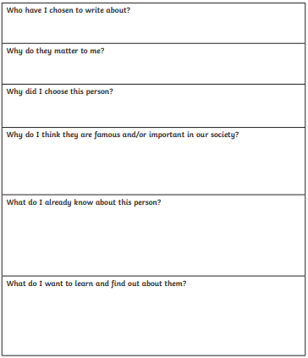
Monday 18th October 2021
L.O: To analyse writing.
C: Biography

Here are some facts I have collected:

