
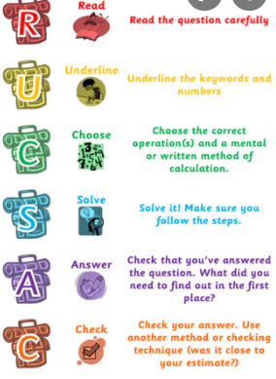
3.11.2021
L.O: To use addition and subtraction
C: Mixed addition and subtraction problems.
Solve these questions in your book using your preferred method.


