
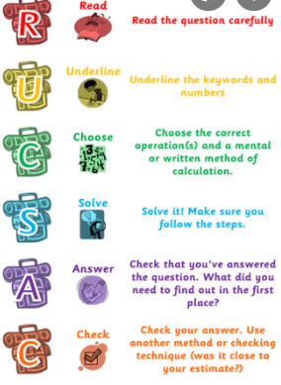
3.11.2021
L.O: To use addition and subtraction
C: Mixed addition and subtraction problems.
Solve these questions in your book using your preferred method.
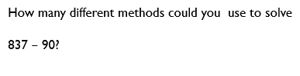
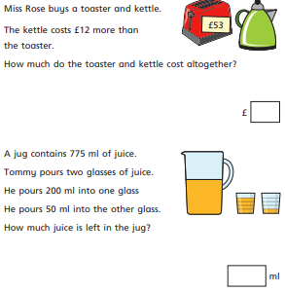
Can you show at least three different methods for solving this question?
Which was your favourite method and why?

