25.2.2022 L.O: To use measures. C: Convert pounds and pence
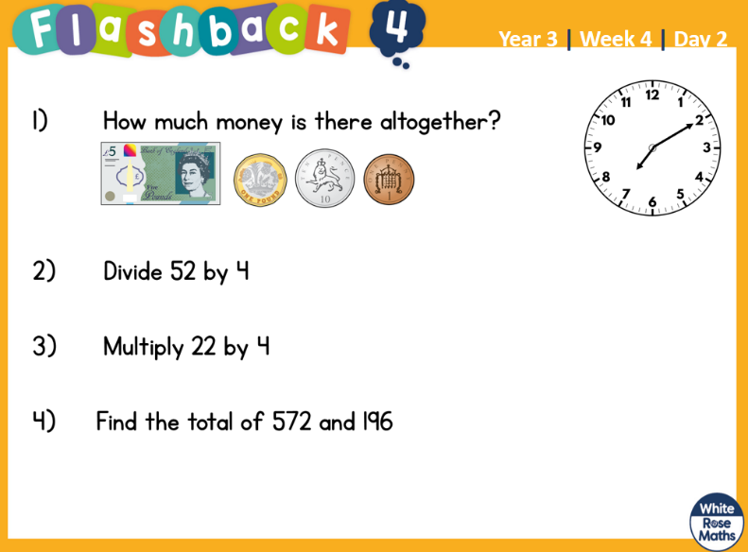

25.2.2022 L.O: To use measures. C: Convert pounds and pence

25.2.2022 L.O: To use measures. C: Convert pounds and pence

