24.2.2022 L.O: To use measures. C: Pounds and pence
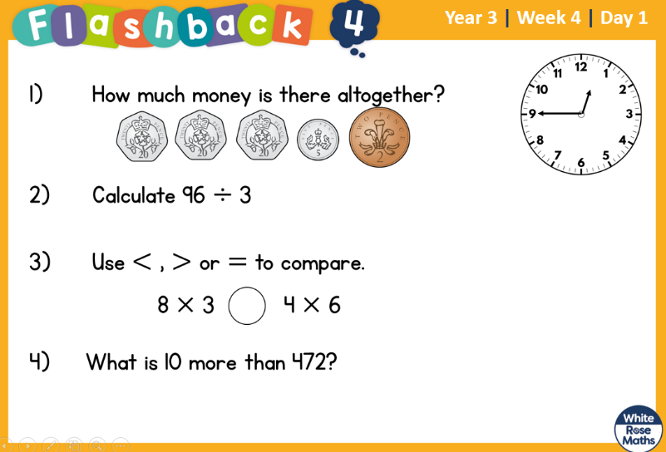

24.2.2022 L.O: To use measures. C: Pounds and pence

24.2.2022 L.O: To use measures. C: Pounds and pence

