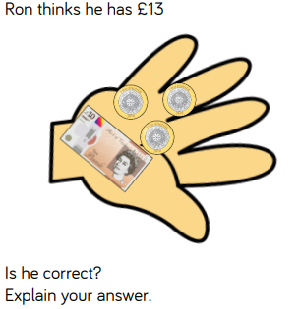
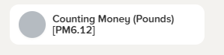


Today we completed this nugget on Century Tech. Here is my score:

Today we completed this nugget on Century Tech. Here is my score:

