23.2.2022 L.O: To use measures. C: Recap count money (pounds)
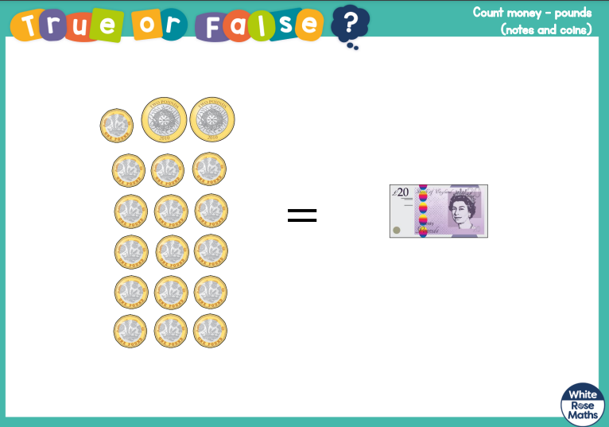
23.2.2022 L.O: To use measures. C: Recap count money (pounds)
23.2.2022 L.O: To use measures. C: Recap count money (pounds)

