22.2.2022 L.O: To use measures. C: Recap count money (pense)
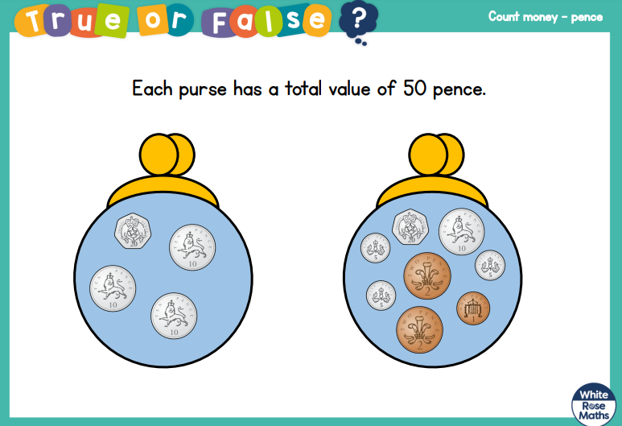

22.2.2022 L.O: To use measures. C: Recap count money (pense)

22.2.2022 L.O: To use measures. C: Recap count money (pense)

