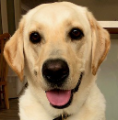
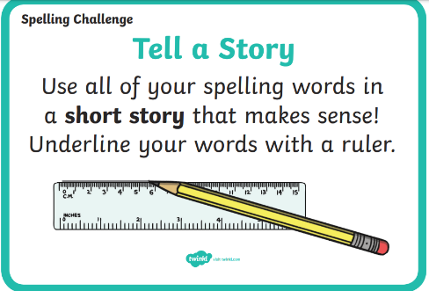
Hi all! Hope you had a fab half 21.2.22 term! This week is “Words! Words! Words!” Week!
Our challenge this week is to learn these words! We are also practicing our handwriting! We will have a competition at the end of the week with 3SG to win an extra playtime!
Here are our words which will be checked on Friday 25.2.2022.
- People
- Animals
- Might
- Terrifying
- Racing
- Therefore
- Enough
- Favourite
- Naughty
- Furthermore
- Our WOW word is efficiently! The children are tasked with using both verbally and in their writing this week.
- The children will also focus on words ending in the suffix –ly, e.g. simply, carefully…

To clarify, the children need to learn the ten blue words, the orange WOW word and practice the spelling pattern -ly.
We are going to be doing a range of activities and games in class, but here are some ideas you can try at home.
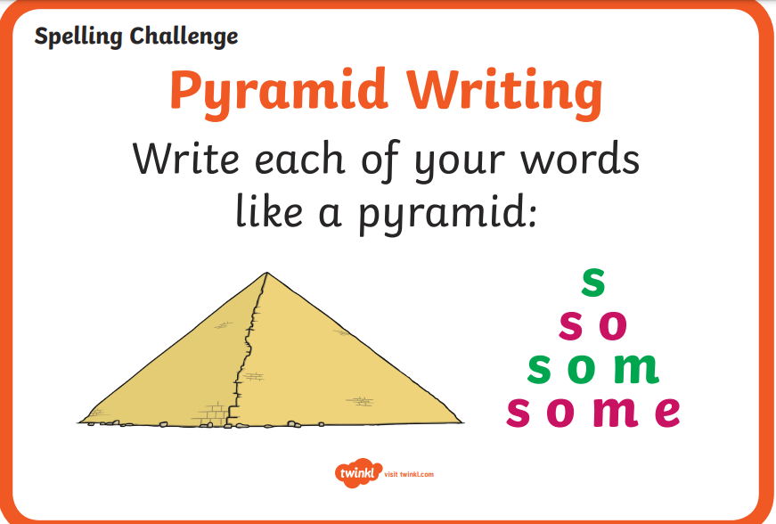
Hi all! Hope you had a fab half 21.2.22 term! This week is “Words! Words! Words!” Week!
Our challenge this week is to learn these words! We are also practicing our handwriting! We will have a competition at the end of the week with 3SG to win an extra playtime!
Here are our words which will be checked on Friday 25.2.2022.
- People
- Animals
- Might
- Terrifying
- Racing
- Therefore
- Enough
- Favourite
- Naughty
- Furthermore
- Our WOW word is efficiently! The children are tasked with using both verbally and in their writing this week.
- The children will also focus on words ending in the suffix –ly, e.g. simply, carefully…

To clarify, the children need to learn the ten blue words, the orange WOW word and practice the spelling pattern -ly.
We are going to be doing a range of activities and games in class, but here are some ideas you can try at home.

