
11.2.2021 L.O: Multiplication and Division
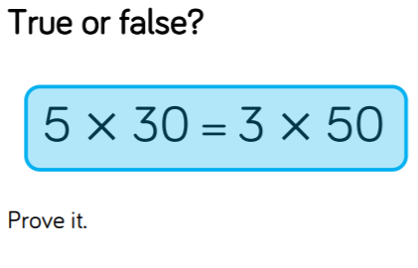
C: Related Calculations.
3)
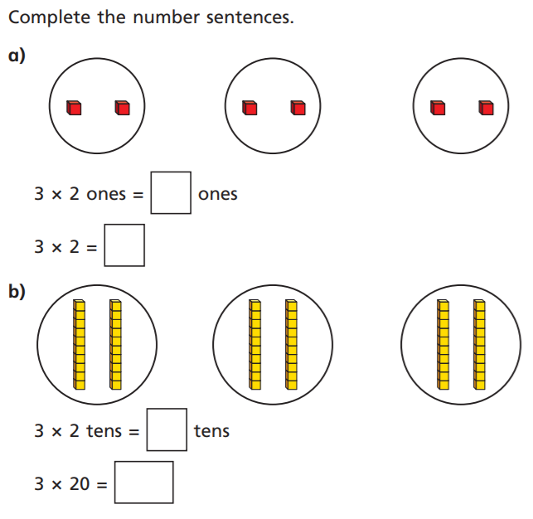
1)

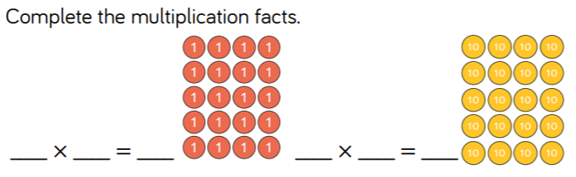
Use the space below to show your working.
2)

