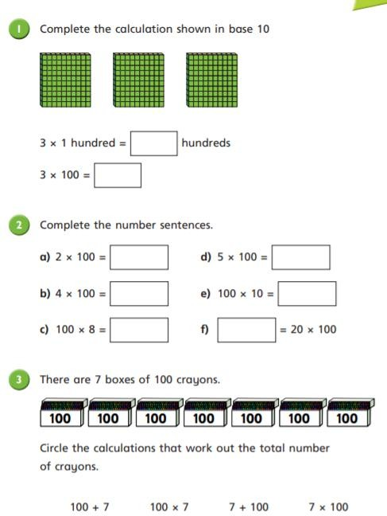

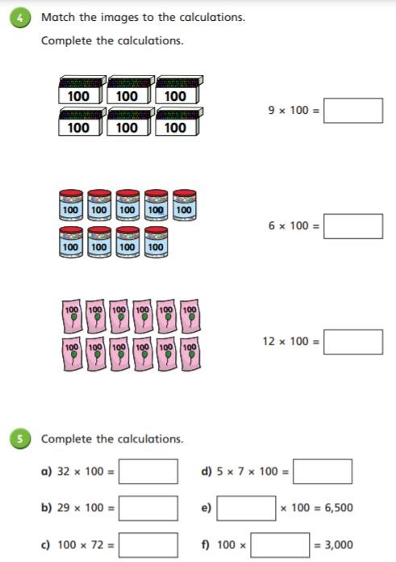

Thank you for using www.freepdfconvert.com service!

Only two pages are converted. Please Sign Up to convert all pages. https://www.freepdfconvert.com/membership

