L.O: To locate places and describe features wb:05.01.22
C: London
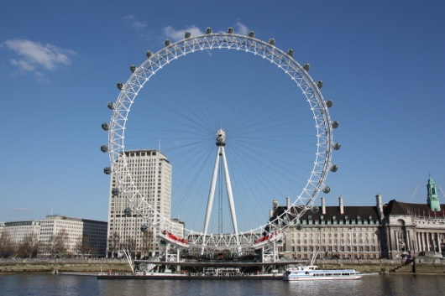
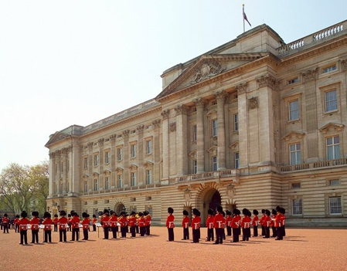
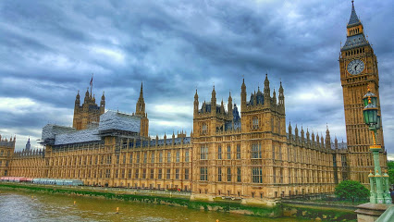
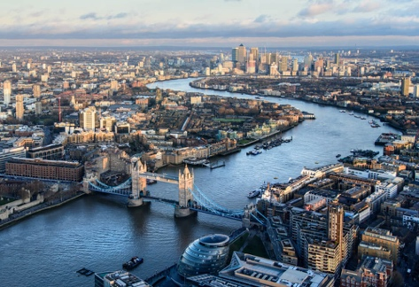
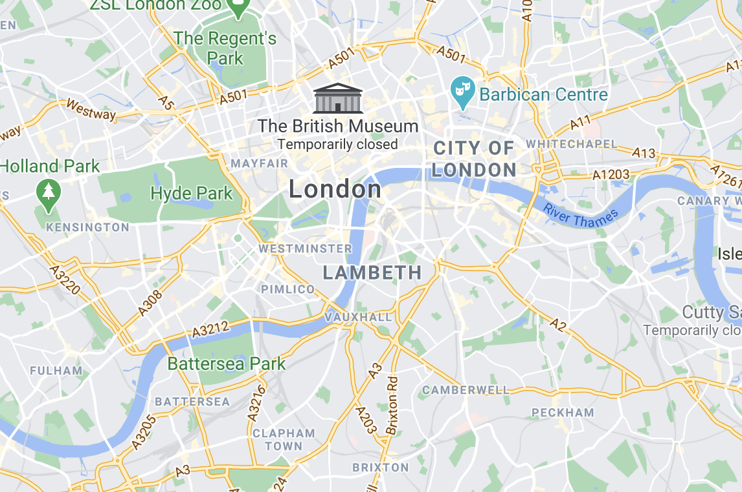

London Eye

Buckingham Palace

Houses of Parliament

River Thames

London Eye

Buckingham Palace

Houses of Parliament

River Thames

