LO: To develop ideas. To master techniques WB 17.01.22
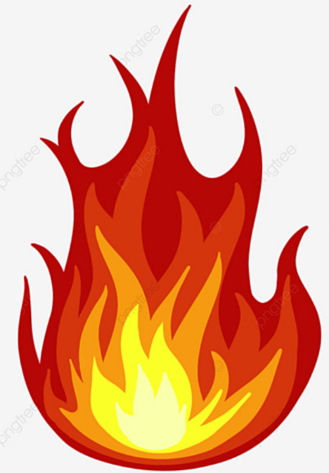
C: Respond to ideas and starting points. Explore ideas and collect visual information. Mix primary colours to make secondary.

What colours can you see? Mix red and yellow to make the different colours in the flame, then fill in the gaps in the sentences.
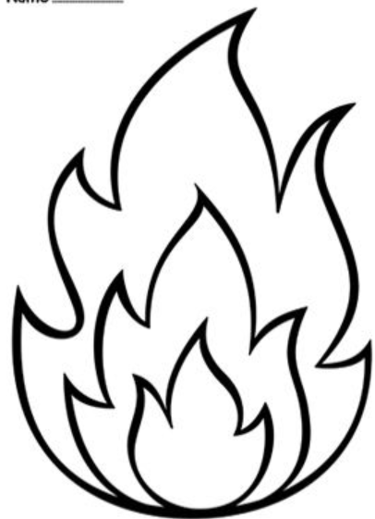

Red is a colour
Yellow is a colour
Orange is a colour.
secondary
primary

Red pen: To make a darker orange when colour mixing you would need to add more and less .
yellow
red

