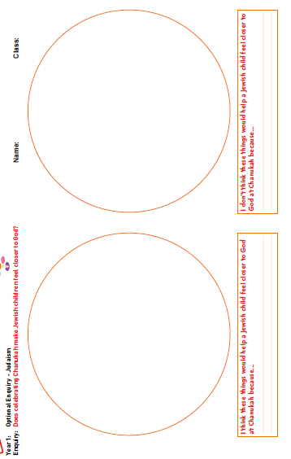
LO: To understand beliefs and teachings Wb 24.01.22
C: Understanding Chanukah

Red pen: What do you think you would enjoy doing at Chanukah and why?


