LO: To understand practices and lifestyles wb 13.12.21
C: The Advent Wreath
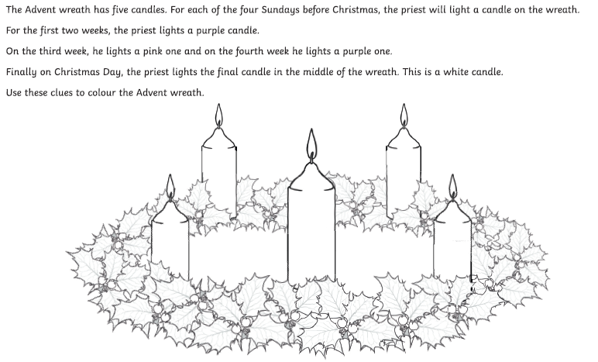
Red Pen: Why do Christians light the last advent candle on Christmas day?

