LO: To understand beliefs and teachings. 25.04.22
C: The Shabbat Table

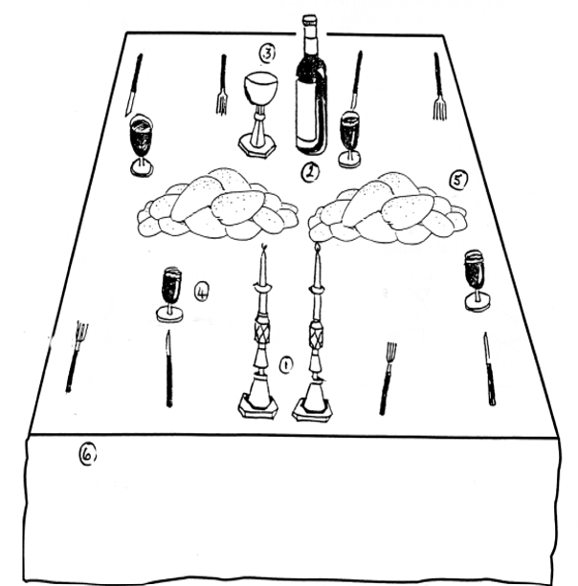

RP - What special traditions do you have in your family?

