To take inspiration wb.25.04.22
To develop ideas
C: Tingatinga Art
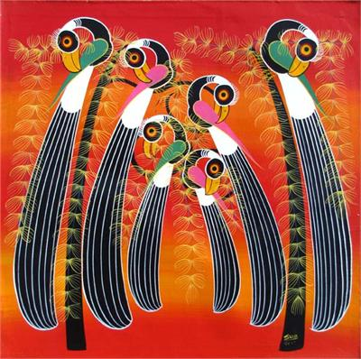
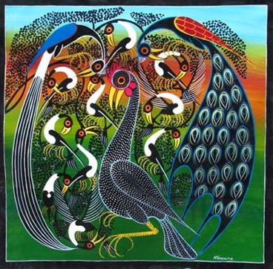
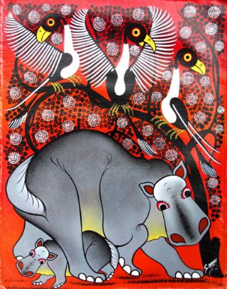

True
False

Bright colours are used. | They are made using paint.
There are animals. | Only the colours black and white are used.
There are humans. | They are made using only pencil.
The colours are accurate. | There are buildings.

Red pencil: How do these pictures make you feel?

____________________________________________

