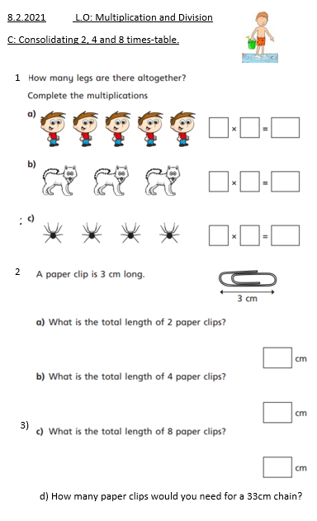

8.2.2021 L.O: Multiplication and Division
C: Consolidating 2, 4 and 8 times-table.
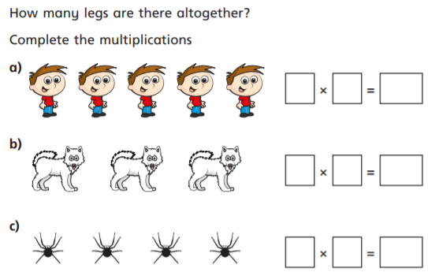
1)

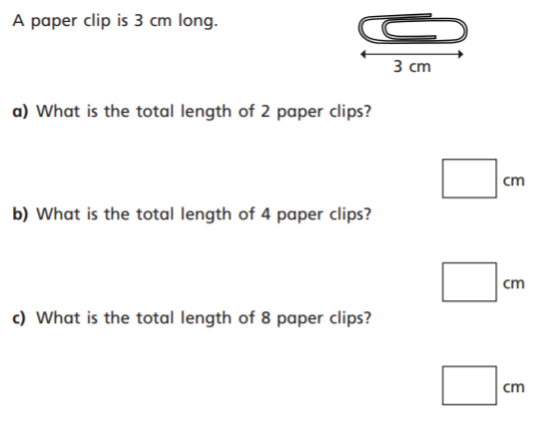
d) How many paper clips would you need for a 33cm chain?
2
3)
2)

