L.O. To develop ideas To master techniques (painting) wb: 10.01.22
- Respond to ideas and starting points.
- Explore ideas and collect visual information.
- Use thick and thin brushes.
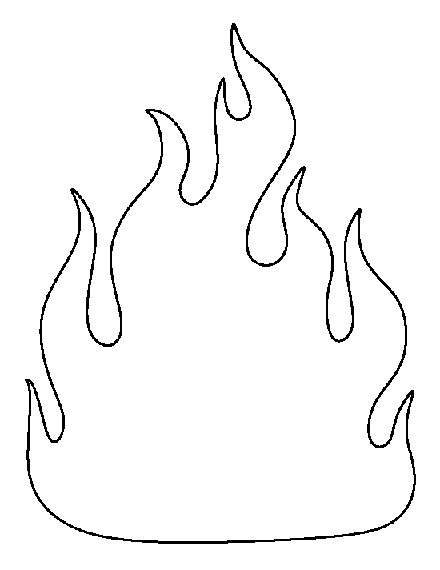
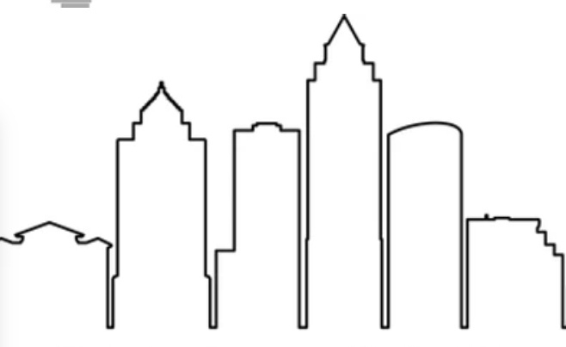
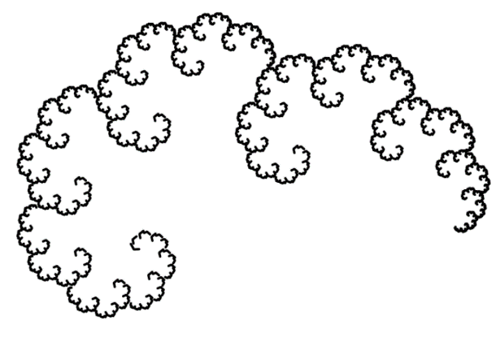
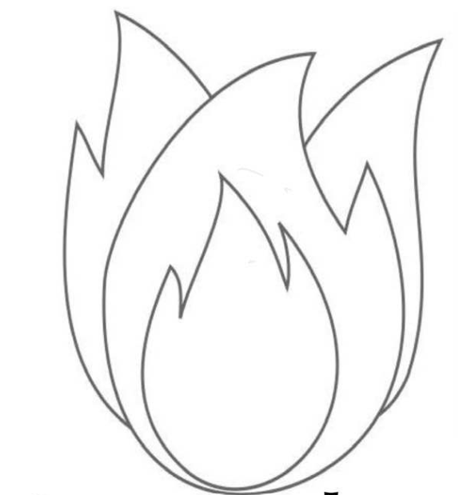
Experiment with different brushes to fill in the spaces. Are some spaces easier with a BIG brush? Are some easier with a small brush?

Red pen - Which brush was better for painting the flames? Why?

