L.O: To understand chronology wb:05.01.22
C: Fire of London

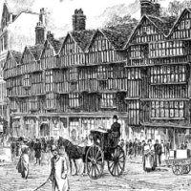
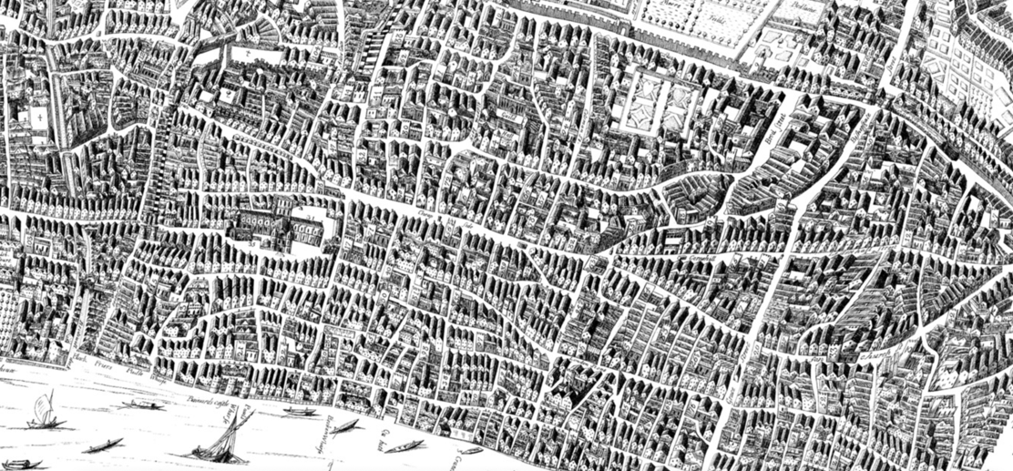
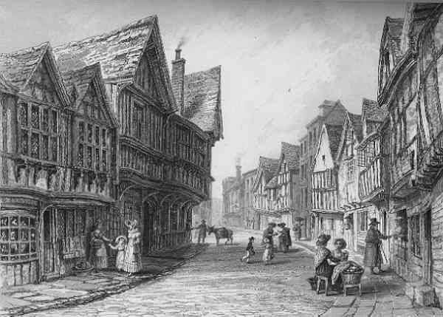
Red pencil: Are these photographs? Or are they something ifferent?

