 Wb: 28.03.22
Mon | RWI  https://www.youtube.com/watch?v=p7hRbrpq5Bo&t=25s | Break | Weaving baskets for biscuits  https://www.youtube.com/watch?v=zBCWVNDliQo | Break | Maths  https://www.topmarks.co.uk/maths-games/5-7-years  Play Toy Shop, Basketball game, Daily 10 etc. to practise concepts learned this year. | Lunch | PE  Dance  https://www.youtube.com/watch?v=d3u1UokDo_o |  | Home time
Tues | RWI  https://www.youtube.com/watch?v=p7hRbrpq5Bo&t=25s |  | Make Easter biscuits  https://www.youtube.com/watch?v=KWsrGkC5DSA |  | English  Saving Easter Reading Comprehension.  PPT and worksheet below |  | Decorate biscuits  https://www.youtube.com/watch?v=KWsrGkC5DSA | BOLE
Weds | RWI  https://www.youtube.com/watch?v=p7hRbrpq5Bo&t=25s |  | Maths/Computing  What is data?  https://www.bbc.co.uk/bitesize/clips/z9svcdm  Create a tally chart and then a class pictogram to represent how children get to school. |  | Easter cards  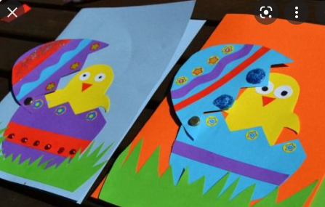 |  | PE  Dance  https://www.youtube.com/watch?v=6JPVKD_UT-Q | Music
Thurs | RWI  https://www.youtube.com/watch?v=p7hRbrpq5Bo&t=25s |  | Maths/computing  Data is stored on a computer:  https://www.bbc.co.uk/bitesize/topics/zbhgjxs/articles/z82v34j  What kind of data do you have stored on your device at home? (photos, stats from games, messages)  Do your own survey on favourite colour. |  | RE  Re-cap the Easter story.  What are the sad parts of the story? What are the happy parts? Discuss how at the end of the story Jesus is resurrected and goes up to heaven to be with God. Explain to chn that this demonstrates the Christian belief that after they die, they can have a new life in heaven.  Heaven by Nicolas Allan Read by Hailey Book#1 - YouTube  Read together the start of Heaven by Nicholas Allen, and discuss both Lil and Dill’s ideas.  Draw a picture of what you think heaven looks like.  If you could ask God one question about heaven, what would it be? |  | Assembly practise
Friday | RWI  https://www.youtube.com/watch?v=p7hRbrpq5Bo&t=25s |  | PSHE  Road safety  How should you cross the road safely? Put the steps in the correct order. |  | Easter assembly |  | Handwriting  Maths minute  Reading  https://www.topmarks.co.uk/maths-games/5-7-years/addition-and-subtraction | Free flow

